2022



 **Mob No.: 7867015510/9025512644/ 73737 48155**

 **Mail:** [**info@agarampowersolution.in**](mailto:info@agarampowersolution.in)

 **Website: www.agaram power solution.in**

 **Address: 37, M.K PURAM MAIN ROAD, NEAR JAIHINDPURAM POLICE STATION, MADURAI-625011.**

,**11/1 A LAXMI VENKATESHWARA NILAYA 2ND CROSS**

**BYRAWESHWARA NAGARNEAR SUNKADAKATTE BUS STOP**

**MAGADI MAIN ROAD SUNKADAKATTE BANGALORE-560091**

INTEGRITY



ABOUT US

**We, Agaram Power solution Industries Leading Manufacturer of LED Lights & SOLAR Products. Agaram power solution Industries as a total energy solution provider in Lighting Industries. We are specialized in high power LED Lighting & Solar Products Manufacturing, through our independent innovation. We assuming high efficient & reliable LED Lighting Solution for YOUR HOME & OUR NATION**

**WHY AGARAM POWER SOLUTION INDUSTRIES:**

* **BETTER PRODUCT**
* **BETTER PROCESS**
* **BETTER RELATIONS**
* **NEW INNOVATIVE IN LIGHTING SYSTEMS**
* **PROVIDING BEST PRE-POST SELLING SERVICES**
* **WE PUT OUR CUSTOMERS AT THE CENTER OF WHAT WE DO**
* **WE VALUE, CHALLENGE & REWARD OUR PEOPLE**
* **WE DRIVE EXCELLENT SUSTAINABLE FINANCIAL PERFORMANCE**
* **OUR BENCHMARK STANDARD IN THE INDUSTRY STANDS ON THE FOUNDATION OF THE HIGH-QUALITY PARAMETERS**
* **QUALITY IS MONITORED AT EACH PHASE OF PRODUCTION ON SUCH PARAMETERS AS CONSISTENT SUPPLY, SAFETY FEATURES, POWER SAVING QUALITY & HEAVY LOAD CAPACITY**
* **CLIENT SATISFACTION IS** **INDEPENDANCE OUR MAIN MOTO BEHIND EVERY WORK**

ALL IN ONE

TUBULAR POLE

FOOLD LIGHT 

SEMIINTEGRATED

SEMI INTEGRATED

SEMIINTEGRATED

Government MODE MModelL

INDEPENDANCE

HIGH MAST



Solar Street Light All in One

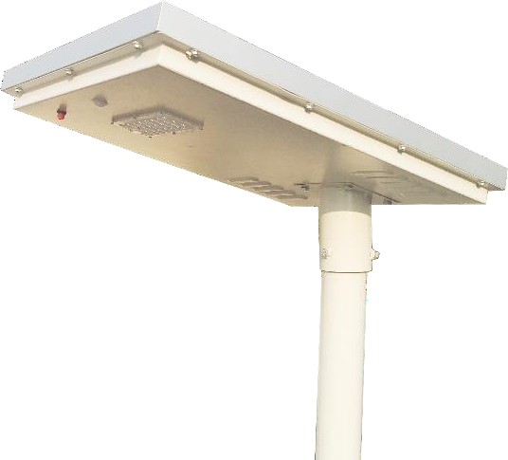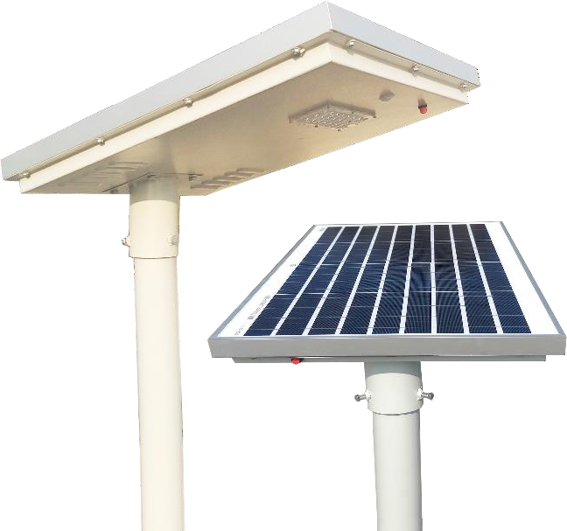

# SPECIFICATIONS

|  |  |
| --- | --- |
| * BIS CERTIFIED Lithium ION Battery * IEC Certified Solar PWM Charge Controller * MNRE/BIS Approved Polycrystalline Solar Panel * Body: Powder Coated Metal * LED Light Lumens: 140/watt * Mounting Height: 4-6 meter Above Ground Level | * Motion Sensor: Passive Infrared Sensor 9 to 12 Meter Range * Dimming after 4 hours * Charge Time: 4 to 6 Hours Good Sunshine * Discharging Time :12-15 Hours * Easy to install & ready to use * Protection: IP67 * *Warranty: 60 Months |

|  |  |  |  |  |  |  |
| --- | --- | --- | --- | --- | --- | --- |
| **Product Code** | **Wattage** | **Panel** | **Battery**  **(12.8v LiFePO4)** | **Lumens** | **Lux** | **Distance** |
| SSL A 7 | 7 | 30w | 6AH | 980 | 12-15 | 4mtr |
| SSL A 9 | 9 | 40w | 12AH | 1260 | 18-22 | 5mtr |
| SSL A 12 | 12 | 40w | 12AH | 1680 | 25-28 | 6mtr |
| SSL A 15 | 15 | 50w | 18AH | 2100 | 32-35 | 7mtr |
| SSL A 18 | 18 | 50w | 18AH | 2520 | 40-45 | 8mtr |
| SSL A 20 | 20 | 50w | 18AH | 2800 | 45-48 | 9mtr |
| SSL A 24 | 24 | 60w | 24AH | 3360 | 54-58 | 10mtr |
| SSL A 30 | 30 | 75w | 30AH | 4200 | 70-75 | 12mtr |
| SSL A 40 | 40 | 100w | 36AH | 5600 | 90-95 | 12mtr |
| SSL A 50 | 50 | 125w | 48AH | 7000 | 110-115 | 12mtr |



Semi Integrated Glass Model

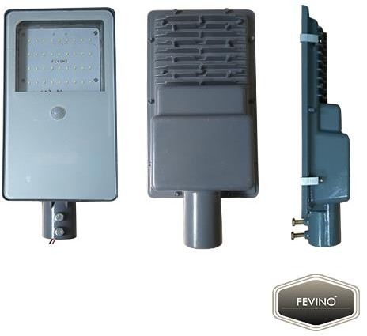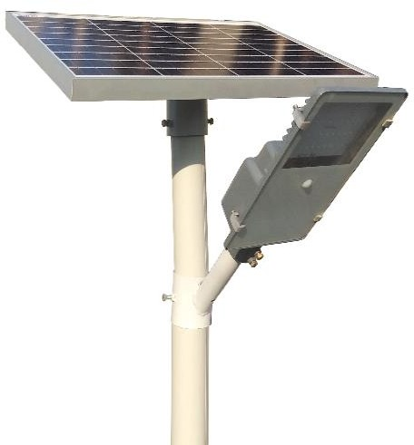

# SPECIFICATIONS

|  |  |
| --- | --- |
| * BIS CERTIFIED Lithium ION Battery * IEC Certified Solar PWM Charge Controller * MNRE/BIS Approved Polycrystalline Solar Panel * Body: Die-Cast Aluminum Metal Stand * LED Light Lumens: 140/watt * Mounting Height: 4-6 meter Above Ground Level | * Motion Sensor: Passive Infrared Sensor 9 to 12 Meter Range * Dimming after 4 hours * Charge Time: 4 to 6 Hours Good Sunshine * Discharging Time :12-15 Hours * Easy to install & ready to use * Protection: IP67 * *Warranty: 60 Months |

|  |  |  |  |  |  |  |
| --- | --- | --- | --- | --- | --- | --- |
| **Product Code** | **Wattage** | **Panel** | **Battery**  **(12.8v LiFePO4)** | **Lumens** | **Lux** | **Distance** |
| SSL G 7 | 7 | 30w | 6AH | 980 | 12-15 | 4mtr |
| SSL G 9 | 9 | 40w | 12AH | 1260 | 18-22 | 5mtr |
| SSL G 12 | 12 | 40w | 12AH | 1680 | 25-28 | 6mtr |
| SSL G 15 | 15 | 50w | 18AH | 2100 | 32-35 | 7mtr |
| SSL G 18 | 18 | 50w | 18AH | 2520 | 40-45 | 8mtr |
| SSL G 20 | 20 | 50w | 18AH | 2800 | 45-48 | 9mtr |
| SSL G 24 | 24 | 60w | 24AH | 3360 | 54-58 | 10mtr |



Semi Integrated Lens Model

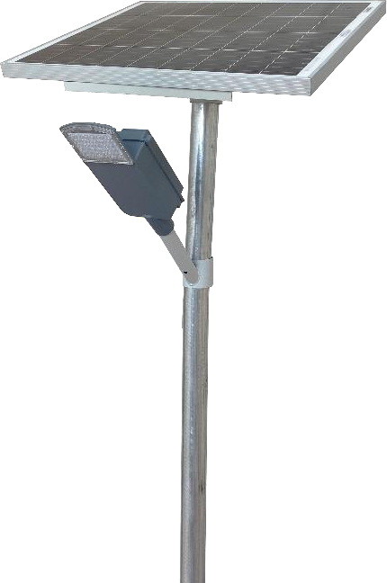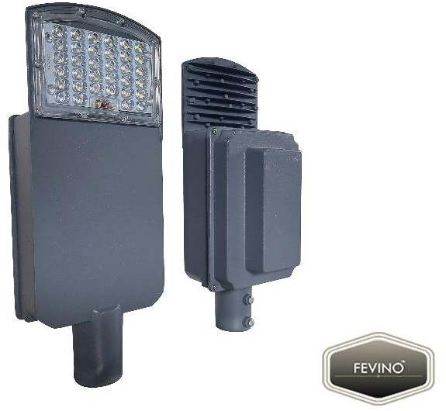

# SPECIFICATIONS

|  |  |
| --- | --- |
| * BIS CERTIFIED Lithium Ferro Phosphate Battery * IEC Certified Solar PWM Charge Controller * MNRE/BIS Approved Polycrystalline Solar Panel * Body: Die-Cast Aluminum Metal Stand * LED Light Lumens: 140/watt * Mounting Height: 4-6 meter Above Ground   Level | * Motion Sensor: Passive Infrared Sensor 9 to 12 Meter Range * Dimming after 4 hours * Charge Time: 4 to 6 Hours Good Sunshine * Discharging Time :12-15 Hours * Easy to install & ready to use * Protection: IP67 * *Warranty: 60 Months |

|  |  |  |  |  |  |  |
| --- | --- | --- | --- | --- | --- | --- |
| **Product Code** | **Wattage** | **Panel** | **Battery**  **(12.8v LiFePO4)** | **Lumens** | **Lux** | **Distance** |
| SSL L 7 | 7 | 30w | 6AH | 980 | 12-15 | 4mtr |
| SSL L 9 | 9 | 40w | 12AH | 1260 | 18-22 | 5mtr |
| SSL L 12 | 12 | 40w | 12AH | 1680 | 25-28 | 6mtr |
| SSL L 15 | 15 | 50w | 18AH | 2100 | 32-35 | 7mtr |
| SSL L 18 | 18 | 50w | 18AH | 2520 | 40-45 | 8mtr |
| SSL L 20 | 20 | 50w | 18AH | 2800 | 45-48 | 9mtr |
| SSL L 24 | 24 | 60w | 24AH | 3360 | 54-58 | 10mtr |
| SSL L 30 | 30 | 75w | 30AH | 4200 | 70-75 | 12mtr |



Government Model Solar Street Light



# SPECIFICATIONS

|  |  |
| --- | --- |
| * BIS CERTIFIED Lithium Ferro Phosphate Battery * IEC Certified Solar PWM Charge Controller * MNRE/BIS Approved Polycrystalline Solar Panel * Body: Die-Cast Aluminum Metal Stand * LED Light Lumens: 140/watt * Mounting Height: 4-6 meter Above Ground   Level | * Motion Sensor: Passive Infrared Sensor 9 to 12 Meter Range * Dimming after 4 hours * Charge Time: 4 to 6 Hours Good Sunshine * Discharging Time :12-15 Hours * Easy to install & ready to use * Protection: IP67 * *Warranty: 60 Months |

|  |  |  |  |  |  |  |
| --- | --- | --- | --- | --- | --- | --- |
| **Product Code** | **Wattage** | **Panel** | **Battery**  **(12.8v LiFePO4)** | **Lumens** | **Lux** | **Distance** |
| MNRE PG 12 | 12w | 75w | 30AH | 1680 | 25-28 | 6mtr |
| MNRE PG 730 | 7w | 30w | 12AH | 980 | 12-15 | 4mtr |
| MNRE PG 740 | 7w | 40w | 12AH | 980 | 12-15 | 4mtr |
| PWD 9 | 9w | 40w | 18AH | 1260 | 18-22 | 5mtr |
| PWD 14 | 14w | 75w | 36AH | 1960 | 30-34 | 7mtr |
| PWD 7w*2 | 7w*2 | 100w | 36AH | 1960 | 45-50 | 8mtr |



Semi Integrated High Wattage

Semi Integrated High Wattage

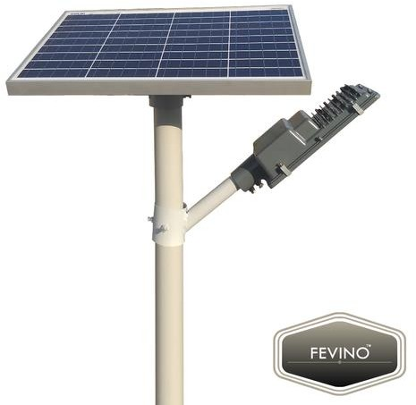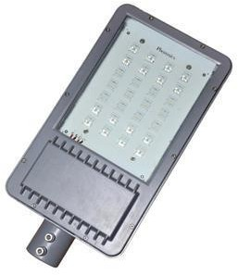

# SPECIFICATIONS

|  |  |
| --- | --- |
| * BIS CERTIFIED Lithium Ferro Phosphate Battery * IEC Certified Solar PWM Charge Controller * MNRE/BIS Approved Polycrystalline Solar Panel * Body: Die-Cast Aluminum Metal Stand * LED Light Lumens: 140/watt * Mounting Height: 4-6 meter Above Ground   Level | * Motion Sensor: Passive Infrared Sensor 9 to 12 Meter Range * Dimming after 4 hours * Charge Time: 4 to 6 Hours Good Sunshine * Discharging Time :12-15 Hours * Easy to install & ready to use * Protection: IP67 * *Warranty: 60 Months |

|  |  |  |  |  |  |
| --- | --- | --- | --- | --- | --- |
| **Product Code** | **Wattage** | **Panel** | **Battery**  **(12.8v LiFePO4)** | **Lumens** | **Lux** |
| SSL HW 40 | 40 | 100w | 36AH | 5600 | 90-100 |
| SSL HW 50 | 50 | 125w | 42AH | 7000 | 120-130 |
| SSL HW 60 | 60 | 160w | 48AH | 8400 | 160-165 |
| SSL HW 80 | 80 | 200w | 60AH | 11200 | 195-200 |
| SSL HW 100 | 100 | 250w | 72AH | 14000 | 250+ |



Solar Flood Light

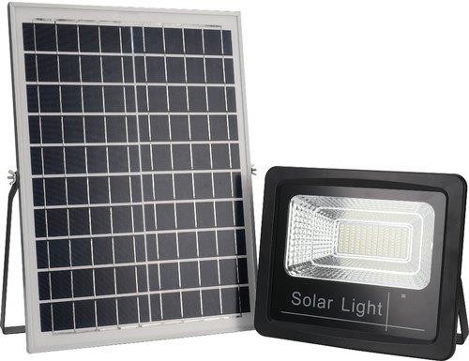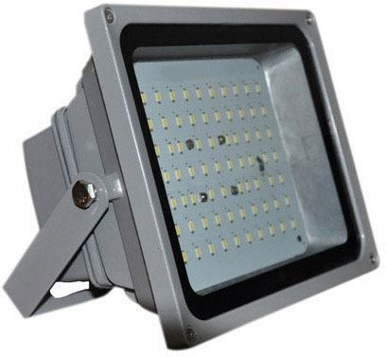

# SPECIFICATIONS

|  |  |
| --- | --- |
| * BIS CERTIFIED Lithium Ferro Phosphate Battery * IEC Certified Solar PWM Charge Controller * MNRE/BIS Approved Polycrystalline Solar Panel * Body: Die-Cast Aluminum Metal Stand * LED Light Lumens: 140/watt * Mounting Height: 4-6 meter Above Ground   Level | * Motion Sensor: Passive Infrared Sensor 9 to 12 Meter Range * Dimming after 4 hours * Charge Time: 4 to 6 Hours Good Sunshine * Discharging Time :12-15 Hours * Easy to install & ready to use * Protection: IP67 * *Warranty: 60 Months |

|  |  |  |  |  |  |
| --- | --- | --- | --- | --- | --- |
| **Product Code** | **Wattage** | **Panel** | **Battery (12.8v**  **LiFePO4)** | **Lumens** | **Lux** |
| SFL 30 | 30 | 100w | 30AH | 4200 | 90-100 |
| SFL 50 | 50 | 160w | 42AH | 7000 | 120-130 |
| SFL 100 | 100 | 250w | 72AH | 14000 | 25-28 |



Solar High Mast Light

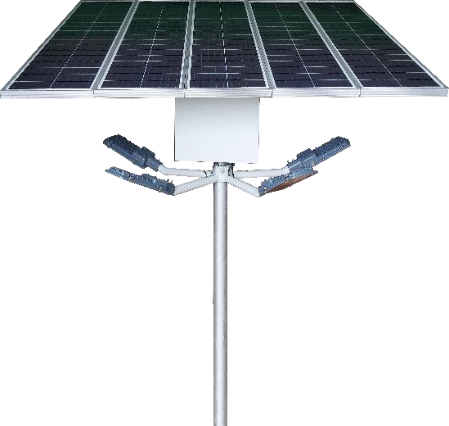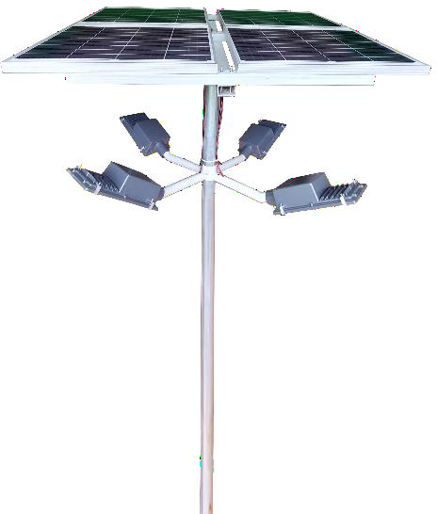

# SPECIFICATIONS

|  |  |
| --- | --- |
| * BIS CERTIFIED Lithium Ferro Phosphate Battery * IEC Certified Solar PWM Charge Controller * MNRE Approved Polycrystalline Solar Panel * Pole: Hot Dip galvanized * LED Light Lumens: 140/watt * Mounting Height: 6 meter Above Ground Level * Easy to install & ready to use | * Motion Sensor: Passive Infrared Sensor 9 to 12 Meter Range * Auto Dusk to Dawn * Dimming after 4 hours * Charge Time: 4 to 6 Hours Good Sunshine * Discharging Time :12-15 Hours * Protection: IP67 * *Warranty: 60 Months |

|  |  |  |  |  |  |  |
| --- | --- | --- | --- | --- | --- | --- |
| **Product Code** | **System Wattage** | **Panel (Watt)** | **Battery (12.8v LiFePO4)** | **No. Of Lights** | **System Wattage** | **Lumens** |
| SHM 20 | 20*4 | 200 | 72ah | 4 | 80w | 11200 |
| SHM 30 | 30*4 | 300 | 120ah | 4 | 120w | 16800 |
| SHM 40 | 40*5 | 400 | 144ah | 4 | 160w | 22400 |
| SHM 50 | 50*4 | 500 | 168ah | 4 | 200w | 28000 |
| SHM 60 | 60*4 | 640 | 192ah | 4 | 240w | 33600 |
| PWD 20 | 20*5 | 400 | 300ah | 5 | 100w | 14000 |



Tubular Pole

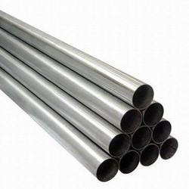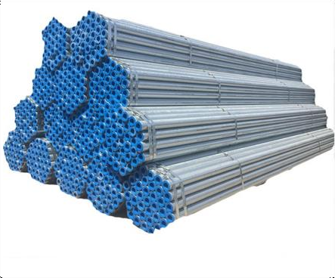

# SPECIFICATIONS

|  |  |
| --- | --- |
| * Galvanized as per IS 2629. * Easy to installation poles. * Superior Finish. * Anti-rust coating. * Mounting Height as per requirement * Easy to install & ready to use | * Strict adherence to quality standards * Planting depth: 1-2mtr * Base plate as per requirement * Foundation J bolt * Greater resistance to corrosion. * Brackets can be customized as per   requirement. |

|  |  |  |  |  |
| --- | --- | --- | --- | --- |
| **Product Code** | **Height** | **Diameter**  **(Top/Bottom)** | **Sheet**  **Thickness** | **Weight** |
| TP 4.5 | 4.5 | 76-76mm | 1.2 mm | 13-16 Kg |
| TP 6 | 6 | 76-76mm | 1.2 mm | 15-18 Kg |



Glass Model AC Street Lights

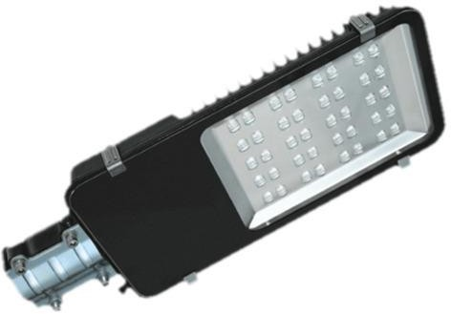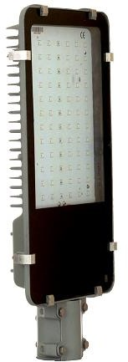

# SPECIFICATIONS

|  |  |
| --- | --- |
| * OSRAM LED * IC HPF Indian Driver(0.96PF) * Typ. Beam Angle: 120° * Aluminum Pressure Die Cast Heat Sink * Clear Transparent Toughened Glass * Aluminum PCB for Better Heat Dissipation * Mounting: Pole Holder Suitable for Adjustable Bracket | * Lumens: 130/watt * Protection: IP67 * Super Durable Epoxy Polyester Powder Coating * Silicon Rubber Gasket * C Clamp for Glass Holding * Universal Input Voltage Range 90- 300VAC, 50Hz * *Warranty: 24 Months |

|  |  |  |  |  |
| --- | --- | --- | --- | --- |
| **Product**  **Code** | **Watt** | **Lumens** | **Lux** | **Distance** |
|  |  |  |  |  |
| SLG 50 | 50 | 6000 | 65 | 8mtr |
| SLG 60 | 60 | 7200 | 70 | 8mtr |
| SLG 72 | 72 | 8640 | 80 | 8mtr |
| SLG 90 | 90 | 10800 | 90 | 9mtr |
| SLG 100 | 100 | 12000 | 110 | 9mtr |
| SLG 120 | 120 | 14400 | 120 | 12mtr |
| SLG 150 | 150 | 18000 | 180 | 15mtr |
| SLG 180 | 180 | 21600 | 190 | 20mtr |
| SLG 200 | 200 | 24000 | 200 | 20mtr |



Frame Model AC Street Lights



# SPECIFICATIONS

|  |  |
| --- | --- |
| * OSRAM LED * IC HPF Indian Driver(0.96PF) * Typ. Beam Angle: 120° * Aluminum Pressure Die Cast Heat Sink * Clear Transparent Toughened Glass * Aluminum PCB for Better Heat Dissipation * Mounting: Pole Holder Suitable for Adjustable Bracket | * Lumens: 130/watt * Protection: IP67 * Super Durable Epoxy Polyester Powder Coating * Silicon Rubber Gasket * C Clamp for Glass Holding * Universal Input Voltage Range 90- 300VAC, 50Hz * *Warranty: 24 Months |

|  |  |  |  |  |
| --- | --- | --- | --- | --- |
| **Product**  **Code** | **Watt** | **Lumens** | **Lux** | **Distance** |
|  |  |  |  |  |
| SLF 50 | 50 | 6000 | 65 | 8mtr |
| SLF 60 | 60 | 7200 | 70 | 8mtr |
| SLF 72 | 72 | 8640 | 80 | 8mtr |
| SLF 90 | 90 | 10800 | 90 | 9mtr |
| SLF 100 | 100 | 12000 | 110 | 9mtr |
| SLF 120 | 120 | 14400 | 120 | 12mtr |
| SLF 150 | 150 | 18000 | 180 | 15mtr |
| SLF 180 | 180 | 21600 | 1900 | 20mtr |
| SLF 200 | 200 | 24000 | 200 | 20mtr |

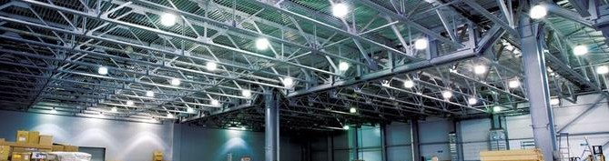

Back Choke Model AC Flood Lights

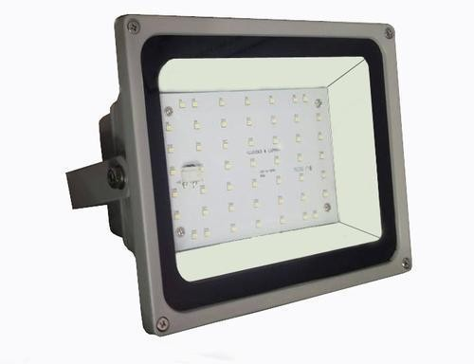

# SPECIFICATIONS

|  |  |
| --- | --- |
| * OSRAM LED * IC HPF Indian Driver(0.96PF) * Typ. Beam Angle: 110° * Aluminum Pressure Die Cast Heat Sink * Clear Transparent Toughened Glass * Aluminum PCB for Better Heat Dissipation * Back Choke High Weight Model | * Lumens: 130/watt * Protection: IP67 * Super Durable Epoxy Polyester Powder Coating * Silicon Rubber Gasket * C Clamp for Flood Light Holding * Universal Input Voltage Range 90- 300VAC, 50Hz * *Warranty: 24 Months |

|  |  |  |  |  |
| --- | --- | --- | --- | --- |
| **Product Code** | **Wattage** | **Lumens** | **Lux** | **Distance** |
|  |  |  |  |  |
| FLB 30 | 30 | 3600 | 50 | 7mtr |
| FLB 50 | 50 | 6000 | 65 | 8mtr |
| FLB 100 | 100 | 12000 | 110 | 9mtr |
| FLB 150 | 150 | 18000 | 120 | 12mtr |
| FLB 200 | 200 | 24000 | 180 | 15mtr |

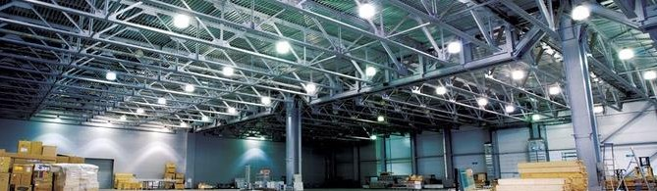

Down Choke Model AC Flood Lights

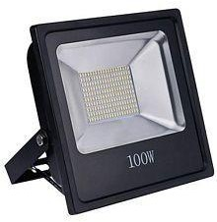

# SPECIFICATIONS

|  |  |
| --- | --- |
| * OSRAM LED * IC HPF Indian Driver(0.96PF) * Typ. Beam Angle: 110° * Aluminum Pressure Die Cast Heat Sink * Clear Transparent Toughened Glass * Aluminum PCB for Better Heat Dissipation * Back Choke High Weight Model | * Lumens: 130/watt * Protection: IP67 * Super Durable Epoxy Polyester Powder Coating * Silicon Rubber Gasket * C Clamp for Flood Light Holding * Universal Input Voltage Range 90- 300VAC, 50Hz * *Warranty: 24 Months |

|  |  |  |  |  |
| --- | --- | --- | --- | --- |
| **Product Code** | **Wattage** | **Lumens** | **Lux** | **Distance** |
|  |  |  |  |  |
| FLD 30 | 30 | 3600 | 50 | 7mtr |
| FLD 50 | 50 | 6000 | 65 | 8mtr |
| FLD 100 | 100 | 12000 | 110 | 9mtr |



ALL RIGHTS RESERVED.

**Reproduction in whole or in part is prohibited. Owing to continues Innovation & Improvement, Agaram Power Solution Reserves the Right to Make Changes in the Data / Details Without Prior Notice. Care has been taken to Ensure that the Information Contained within is Correct.**

OFFICE :

AGARAM POWER SOLUTION,

37,M.K PURAM MAIN ROAD,

NEAR JAIHINDPURAM POLICE STATION,

MADURAI-625011.

79,11/1 A LAXMI VENKATESHWARA NILAYA 2ND CROSS

BYRAWESHWARA NAGARNEAR SUNKADAKATTE BUS STOP

MAGADI MAIN ROAD SUNKADAKATTE BANGALORE-560091

NO.277,ROAD-0604,ALKHARIJIYAH 0606,

CAPITAL GOVERNORATE,BAHRAIN.

CONTACT NO : **7867015510/ 9025512644/73737 48155**

MAIL : [info@agarampowersolution.i](mailto:info@fevino.in)n Website : [www.agarampowersolution.in](http://www.agarampowersolution.in)